Scott County Board of Supervisors

**Instructions for *Unmuting Phone Line* during Board Meeting teleconference**

To gain the moderator’s attention*,* ***press *3 from your phone OR the raise hand icon*** on computer or mobile device (for location of raise hand icon, see below). Phone lines will be placed on mute during the meeting. Participants may unmute their line using the mute icon or **\*6** on their phone after being recognized by the Chair.

**Meeting #2488 799 8582**

**Password #1234**

**Connect via Computer or application:**

Host: [www.webex.com](http://www.webex.com) Meeting number: **above** Password: **1234**

Or use direct link to meeting: <https://scottcountyiowa.webex.com/scottcountyiowa/onstage/g.php?MTID=e21a13e349f62b73d4fd4680046f0cebd>

**Connect via telephone: 1-408-418-9388** Meeting number: **above** Password: **1234**

**Telephone / Cell Phones Connections:**

Telephones lines will be placed on mute during the meeting. Participants may “raise their hand” by using *3 to gain attention of the host.

When called upon for comments by the Board,

1. The host will then unmute the participant’s line at the appropriate time.
2. A user must have his or her own device unmuted.
3. The user may then unmute his or her conference line by keying * 6
4. After conversation, please lower your hand. (*3 again)

**Computer / Application Connections:**If connected via web application or computer, the user should look for the raise hand symbol and click to appear raised so the host may acknowledge you.

1. The host will then unmute the participant’s line at the appropriate time.
2. A user must have his or her own device unmuted.
3. The user may then unmute his or her conference line by clicking the microphone symbol.
4. After conversation, please lower your hand. (*3 again)

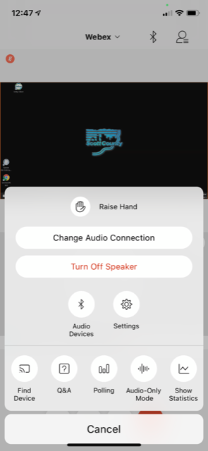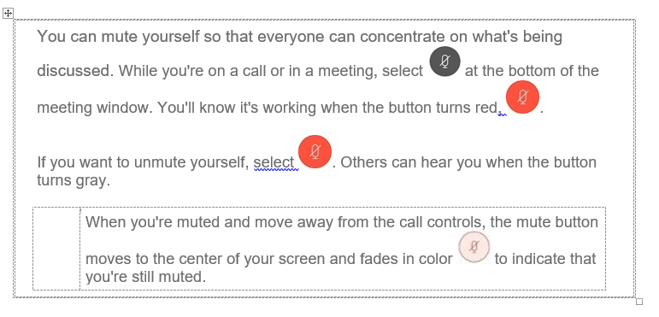

To find the ***raise hand icon***, you may need to click on …